**GROUP FINAL PROJECT REPORT**

**CONTENT LIST**

1. MEMBER LIST
2. PROJECT IDEA
3. PROJECT REPORT
4. SUMMARY

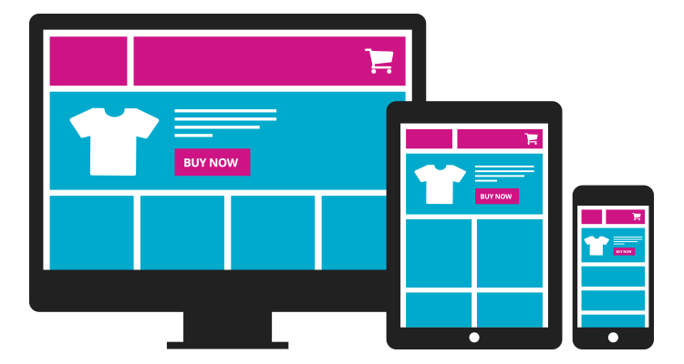

1. ***Group member:***

|  |  |  |
| --- | --- | --- |
| ***No.*** | ***STUDENT ID*** | ***STUDENT NAME*** |
| *1.* | *2059006* | *LÊ ANH DŨNG* |
| *2.* | *2059013* | *QUÁCH PHÚ HÀO* |
| *3.* | *2059042* | *NGUYỄN HOÀNG TRƯỜNG THỊNH* |
| *4.* | *2059043* | *HÀ MINH THUẬN* |

1. ***Project Idea:***
2. Idea: ECommerce Website
   * Selling Technology Items such as Keyboard, Switches, Keycap, etc.
3. Features:

* Admin account, Customer account.
* Log in, Log out.
* Comment (for Customer)
* Add, Delete, Update (only for admin account)
* Add, Delete, Update (shopping cart)

1. ***Project Report:***

* **Completed:**
* Admin Account, Customer Account
* Admin Account: Username: admin Password: admin
* Customer account:
* The customer needs to register an account to be able to log in. The login function will not work if the customer has not registered an account or entered the incorrect information.

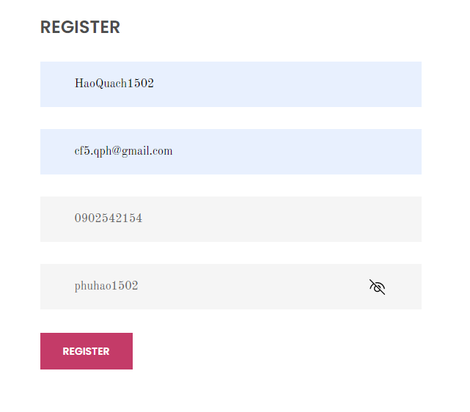

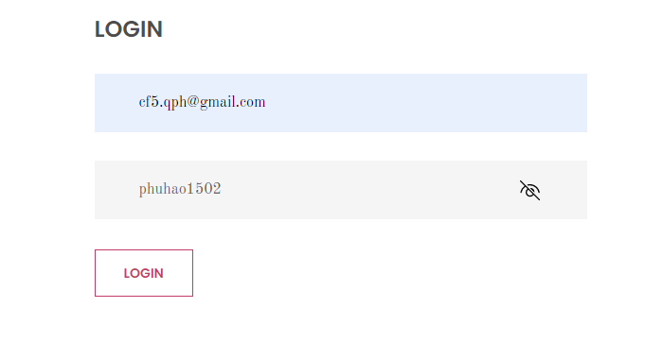

* Log in, Log out
* Our team has performed functions such as logging in and logging out for both Admin Account and Customer Account.   
    
  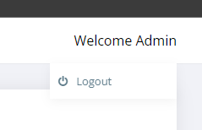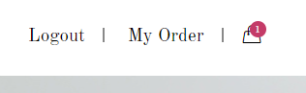
* Comment (for Customer)
* The Customer can leave a comment on the website at Tab CONTACT. After sending the message (comment), customers will receive a reply as a thank you from the website immediately.  
    
    
  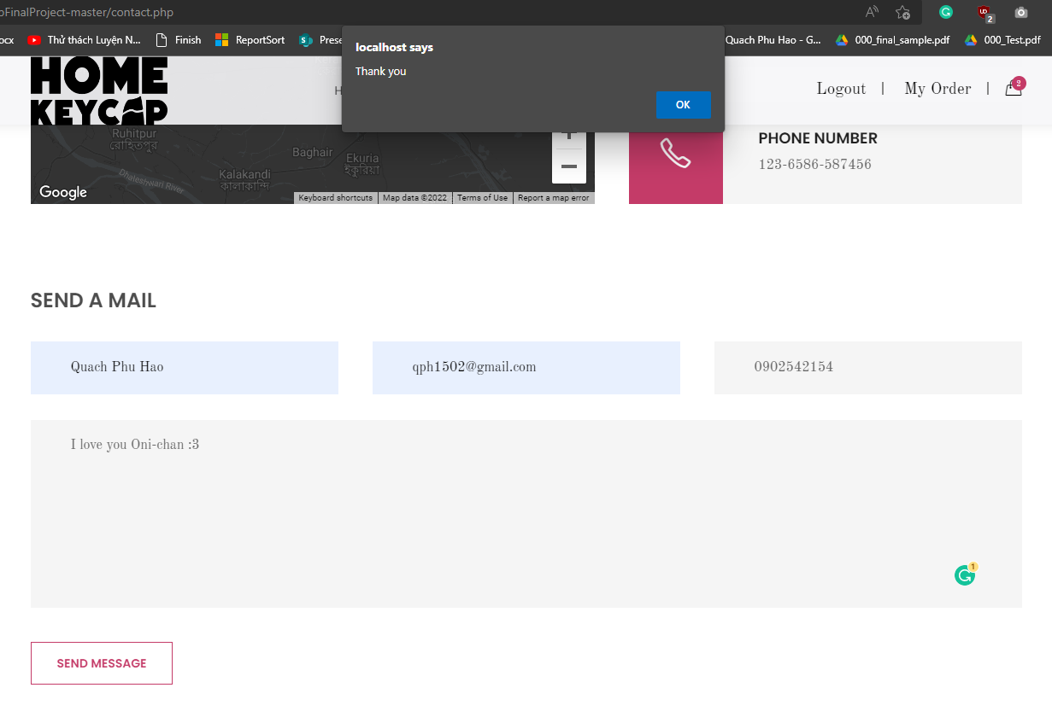
* Add, Delete, Update (Admin Account)
* Admin Account can Add Categories Master and Products Master (can also Edit, Delete, or Active and DeActive those information's).  
    
    
  Add, Delete, Update Categories function:  
  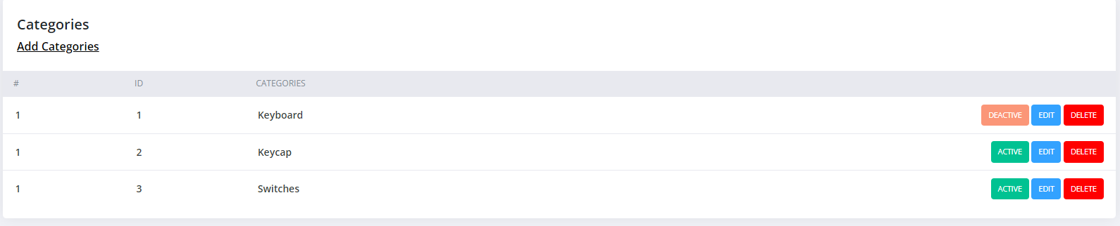  
  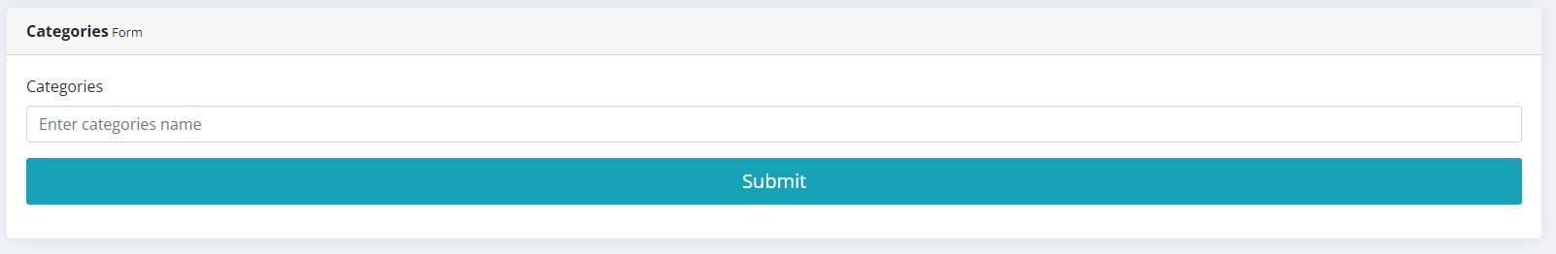  
    
  Add, Delete, Update Product function:   
  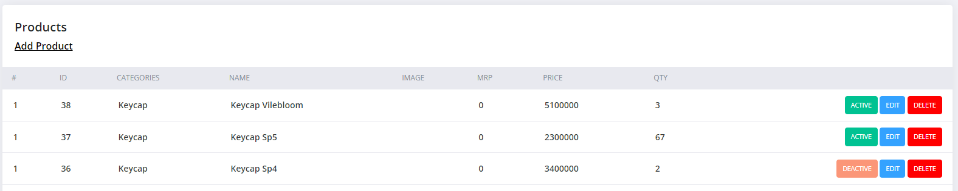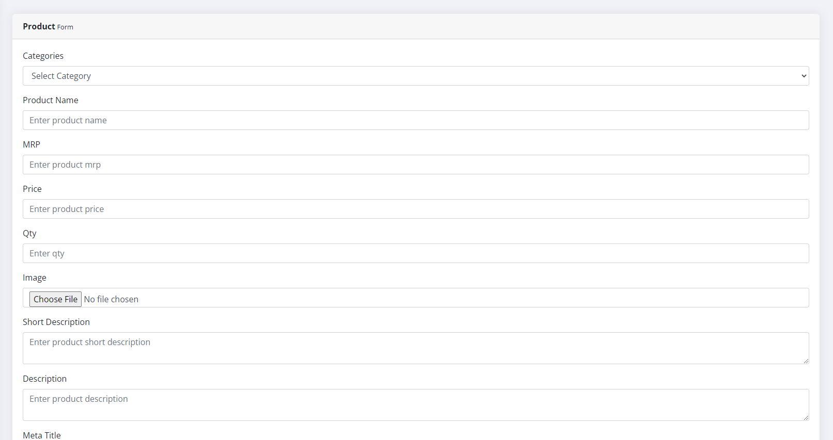
* Add, Delete, Update (Cart)
* The Customer can add items to the Cart, also delete and update Cart and checkout the cart:
* First, the customer clicks on the picture of the product they want to buy.
* Second, select the number of products they want to buy from 1 to 10 at the Qty box.
* Last, click Add to cart.  
  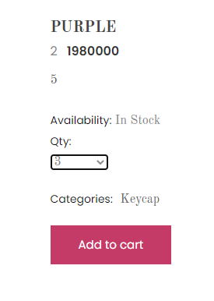
* At the Cart tab, the customer can update the quantity of each product in the Quantity row, or also delete the products in the Remove row that they do not want to buy anymore.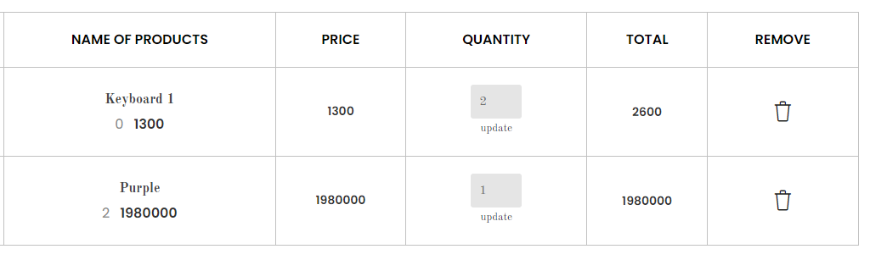

1. ***Summary:***

* According to the goals we set, we achieved 5/5 of the goal, which means we achieved 100% of the overall goal.